**CHATBOT DEPLOYMENT WITH IBM CLOUD**

**WATSON ASSISTANT**

**PHASE 3: DEVELOPMENT PART 1**

In IBM Watson assistant, which is a cloud based conversational AI platform, entities, intents and dialogs are key components used to build and train chatbots or virtual assistants

Now we are going to create the chatbot for that we will do the primary steps now.

**STEP 1**

Login To the IBM account and click on the Catalog and then search for Watson Assistant and give enter.

You will get the Watson Assistant There By default you will have this

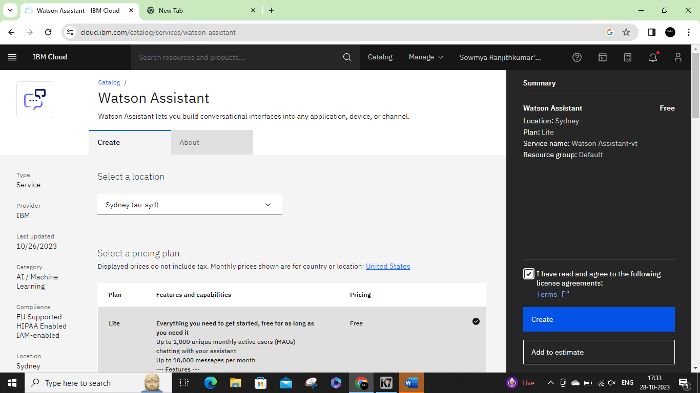

Change the default location and give your location and select the plan as Lite. Now click on create it will create an instance for you.

**STEP 2**

After creating an instance for Watson Assistant you need to launch the Watson Assistant by clicking the launch the assistant.

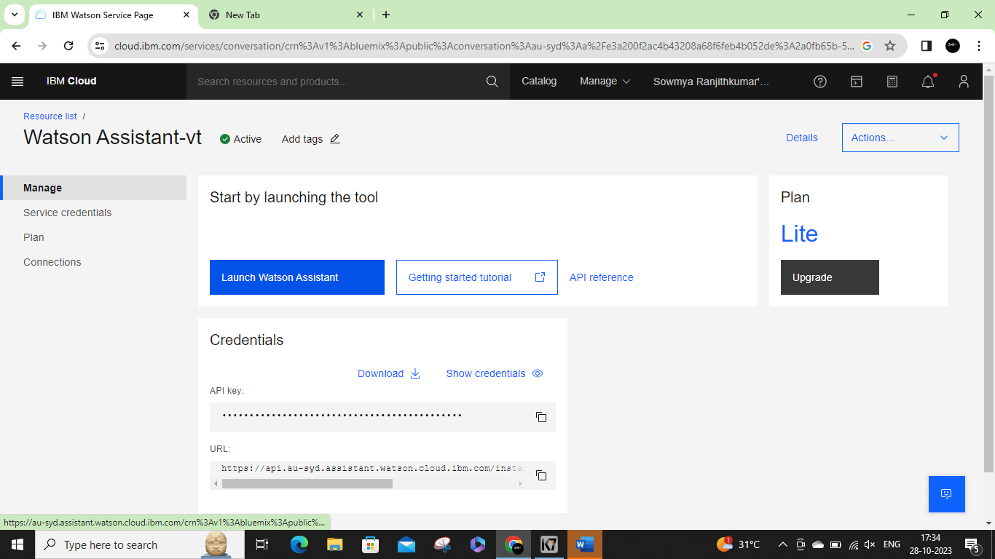

**STEP 3**

* It will give the access to create the assistant give the name for the Assistant and give the description for that assistant it's completely optional click on create and save it.
* Here I have been created BUGBUSTER BOT as my chat bot assistant name.

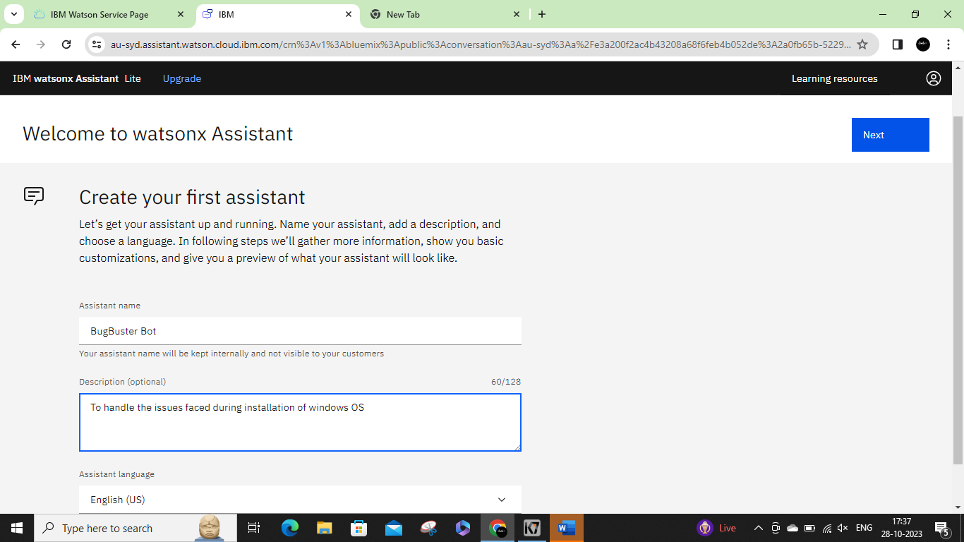

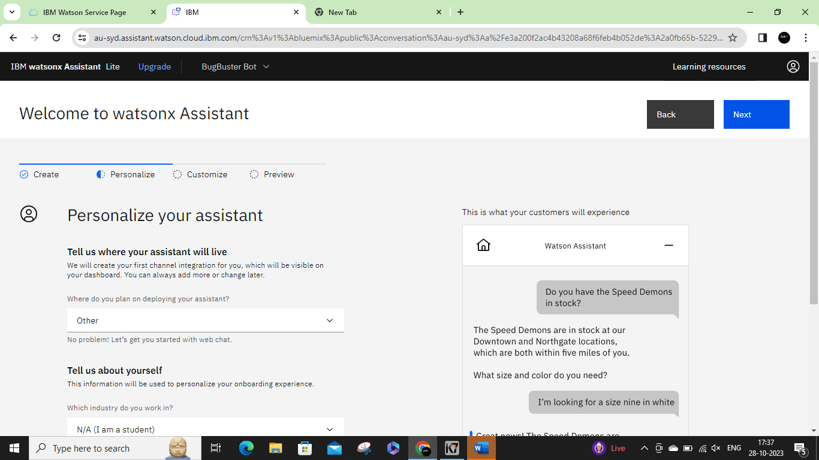

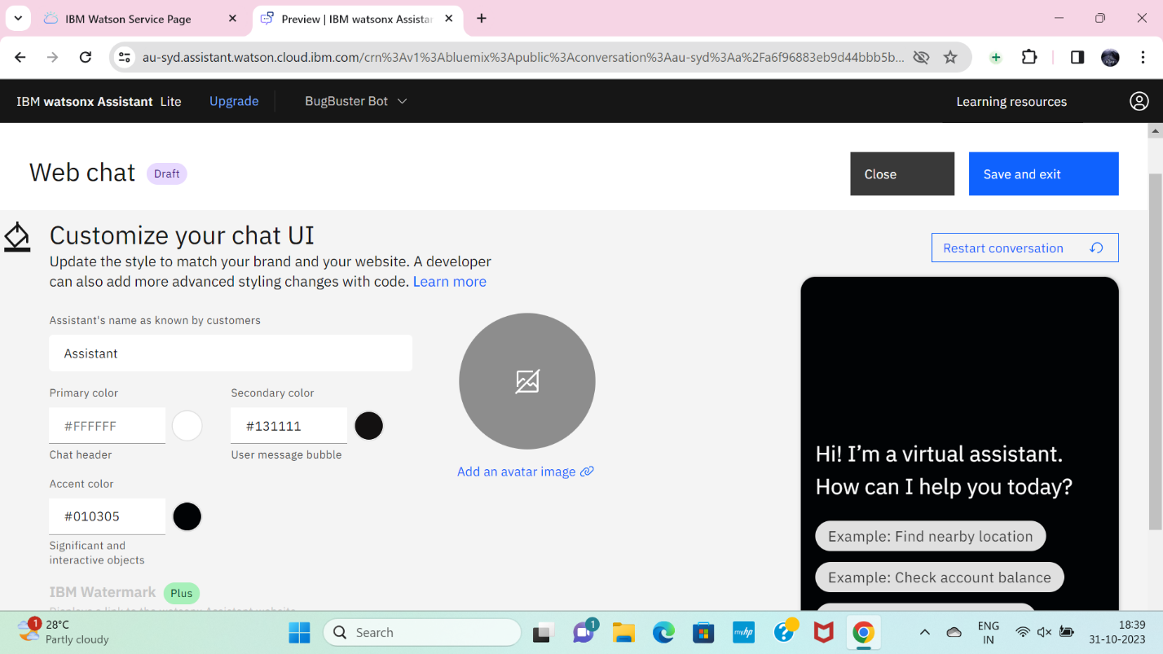

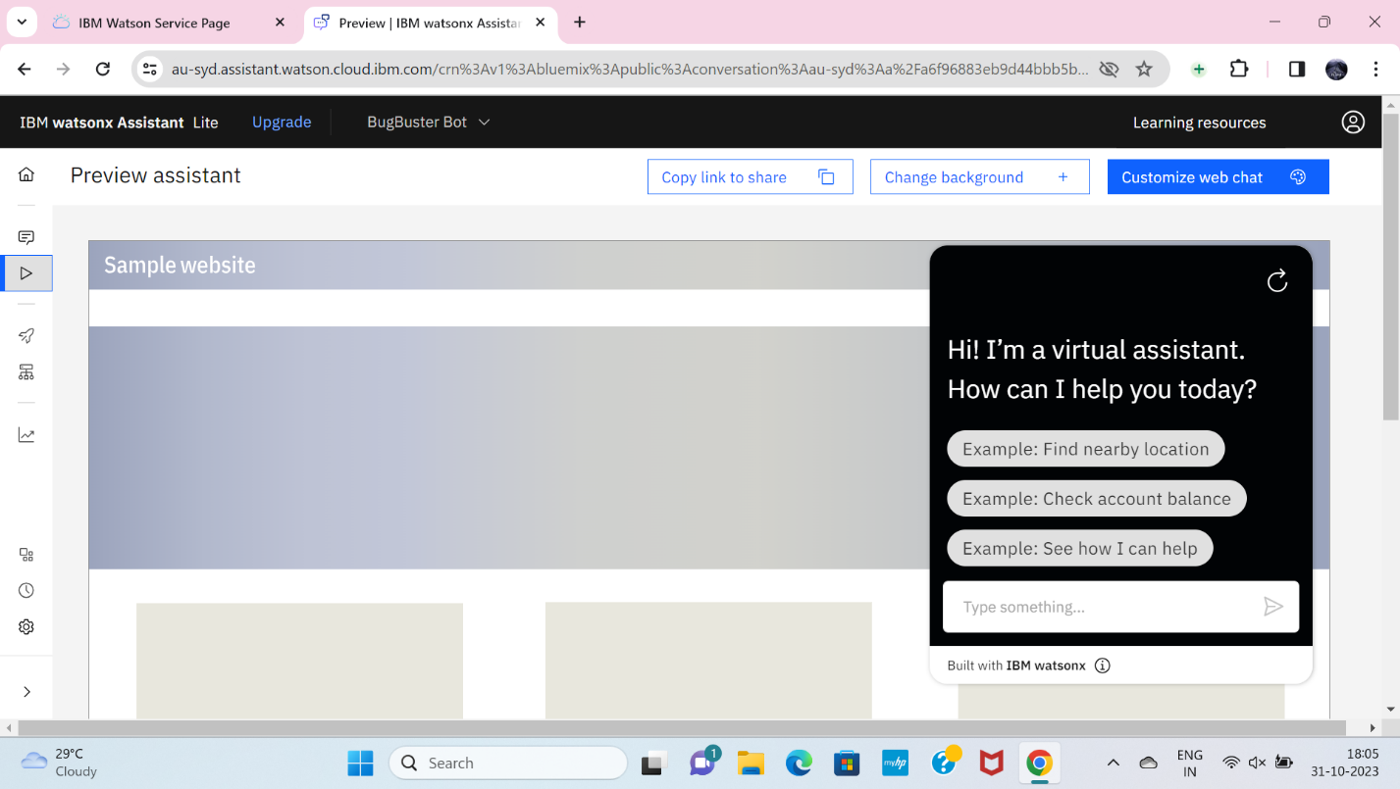

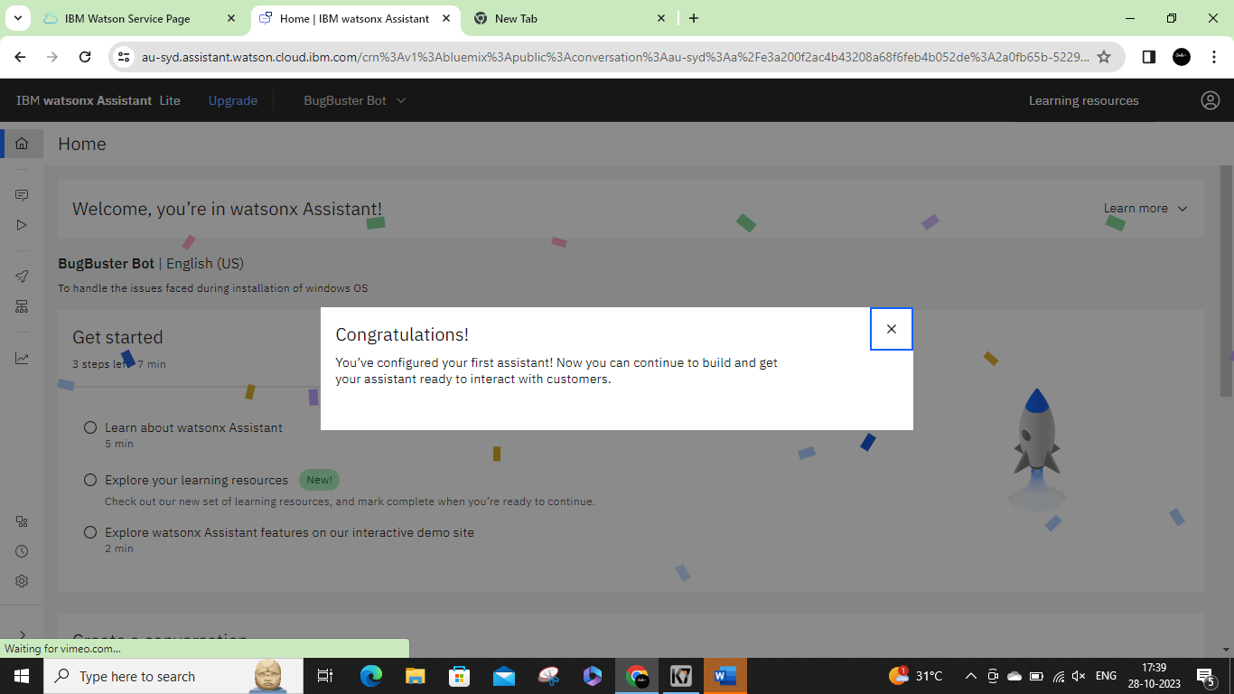

**STEP 4**

In the assistant settings, scroll down and then activate the dialog.

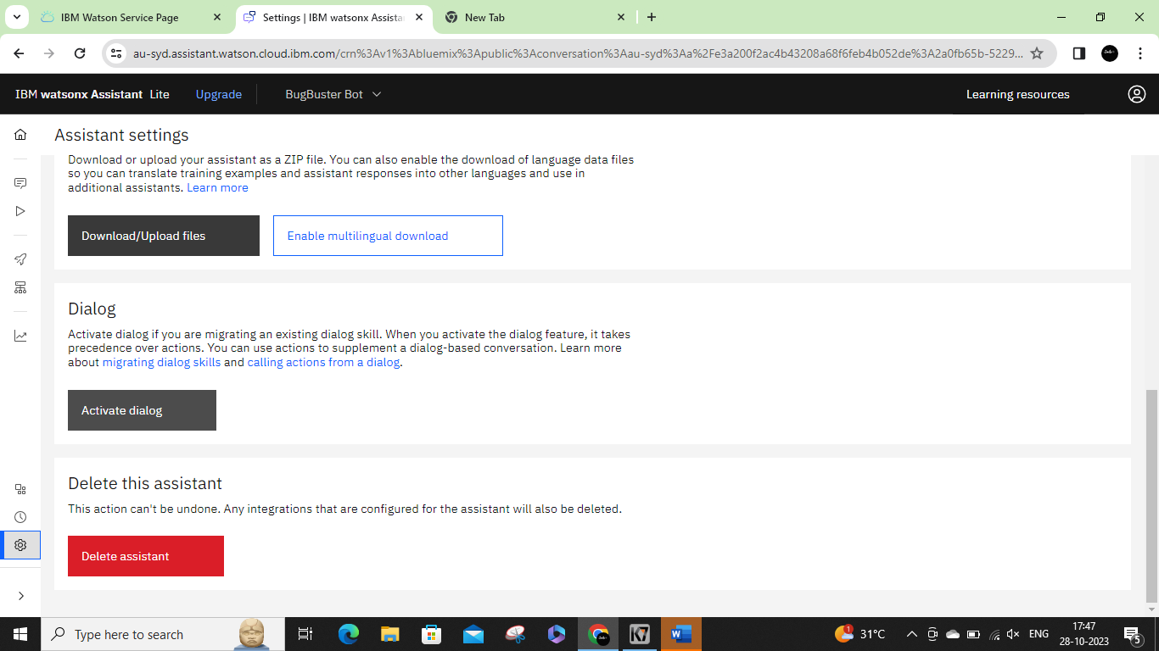

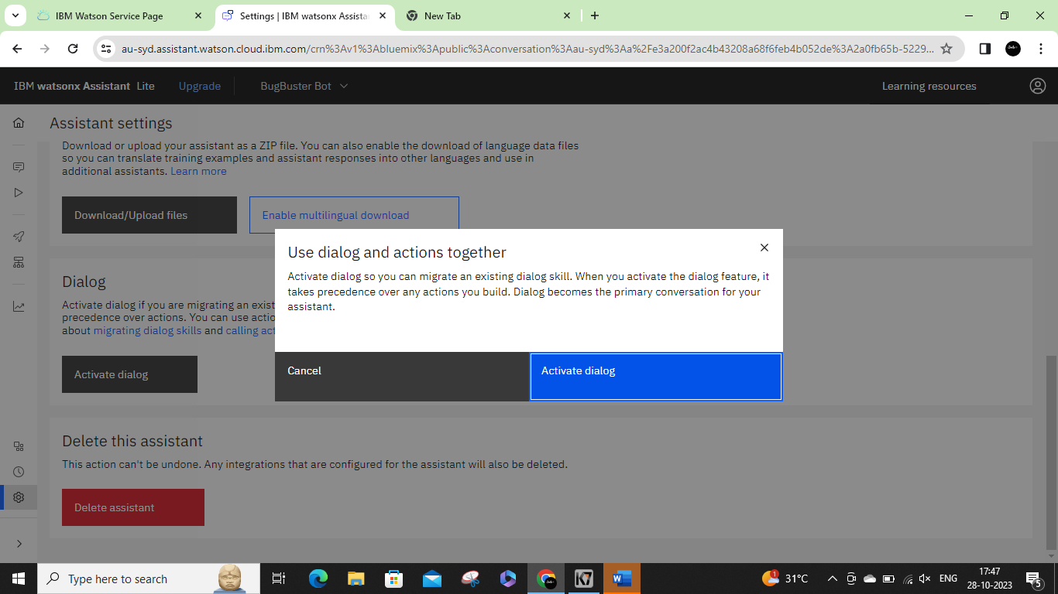

**STEP 5**

After activating the Dialog, you will get the Intents, Entities, Dialog, and Content catalog like shown below

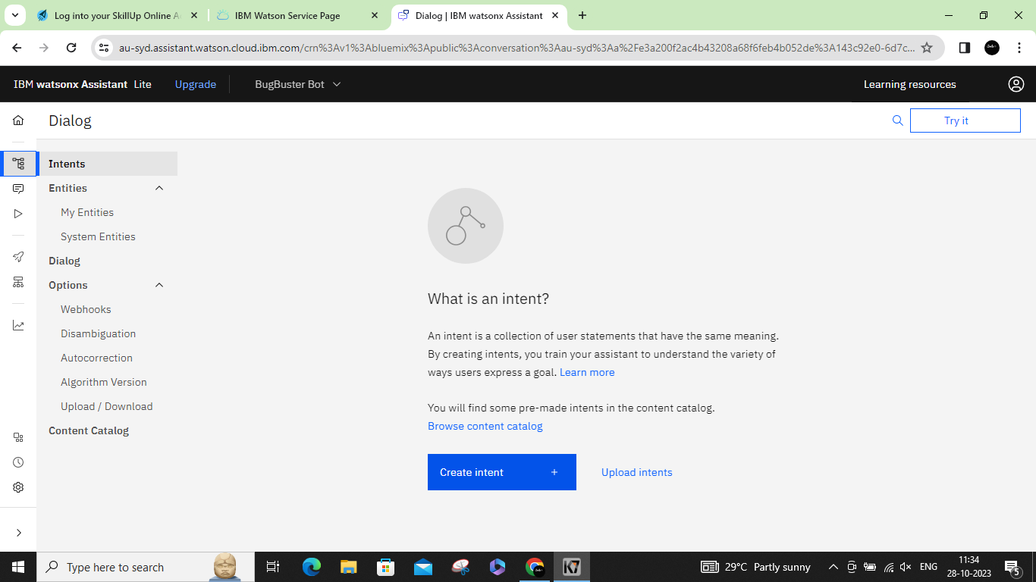

**STEP 6**

Create the intents

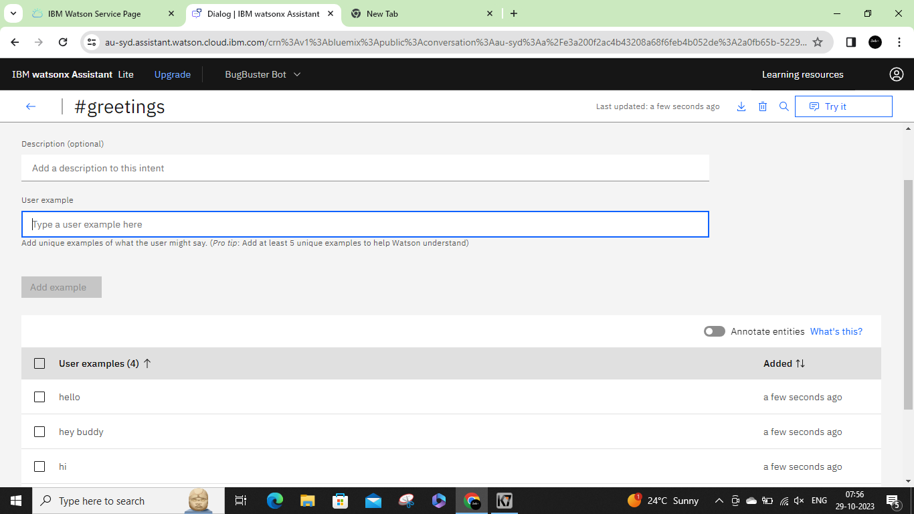

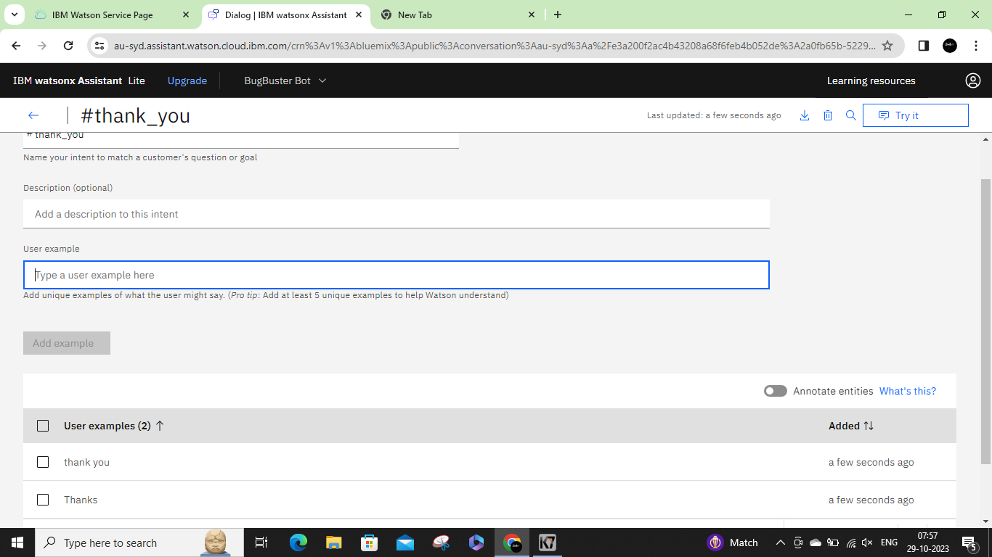

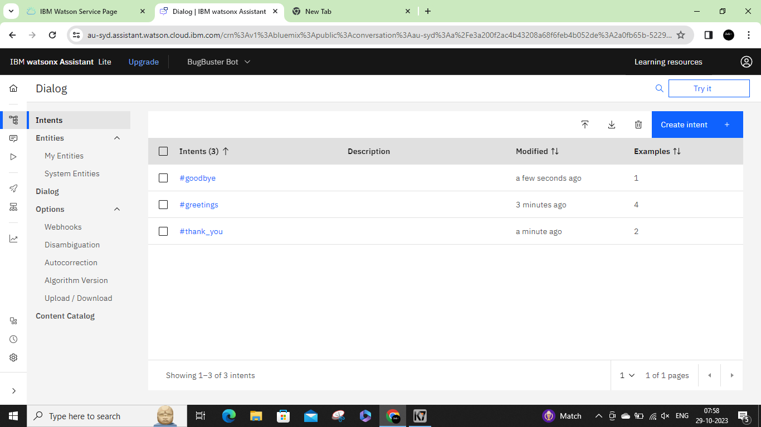

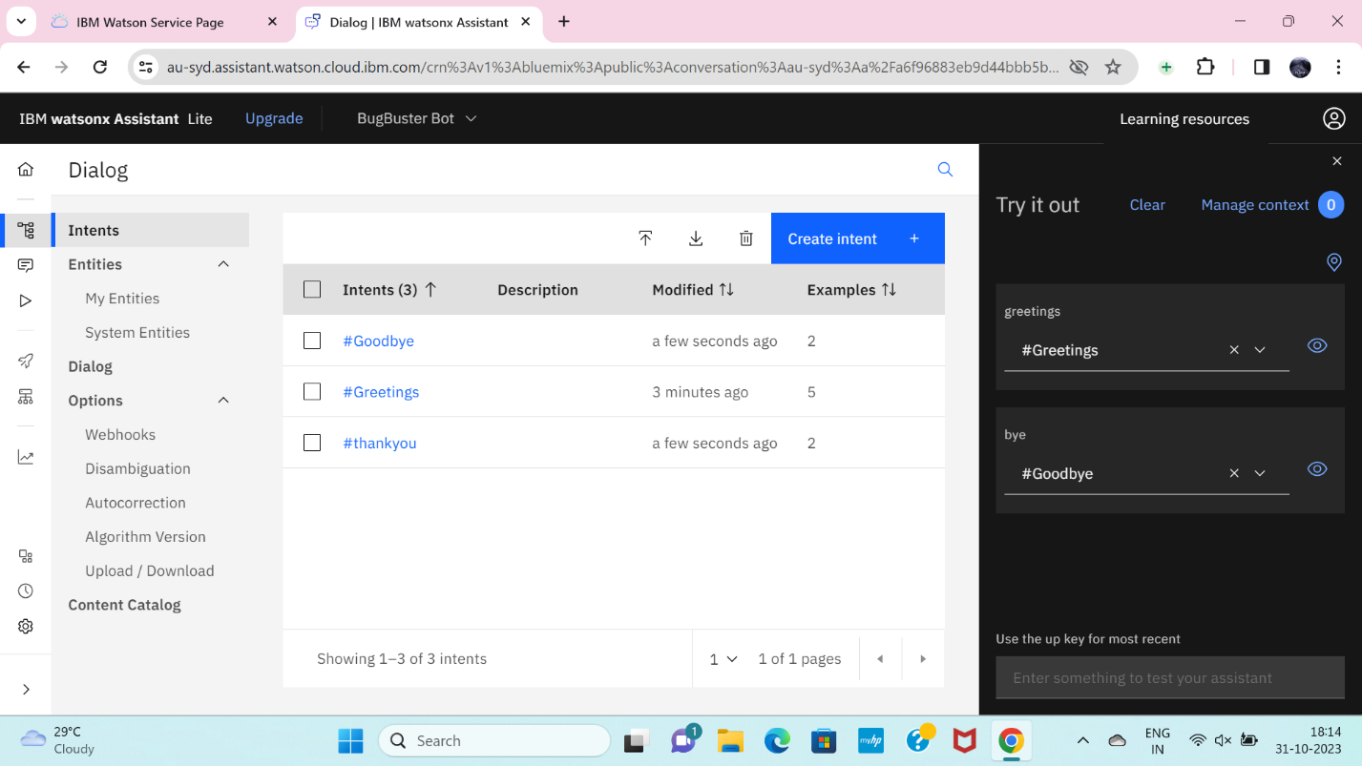

**STEP 7**

Create the Entities first and one variables for the entities you have been created.

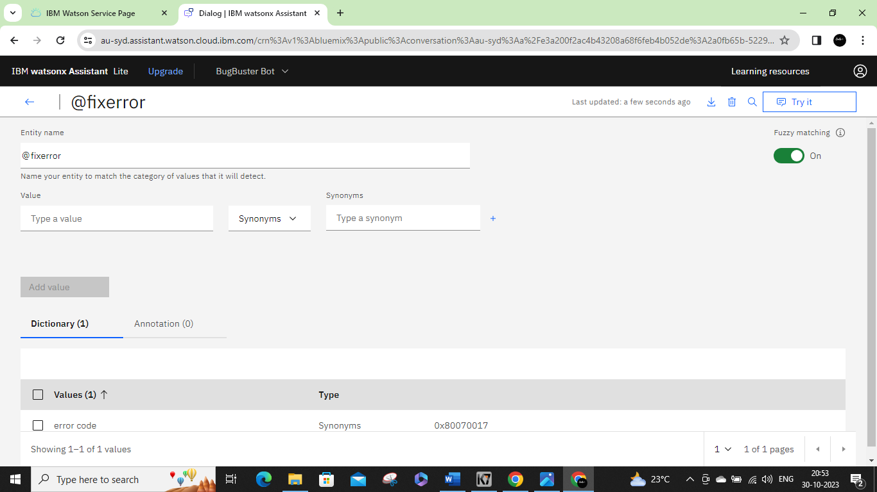

**STEP 8**

Next open the Dialog and then add nodes for all the Intents you have created where we need to give the responses for the selected queries. Whereby default we will have Anything else node.

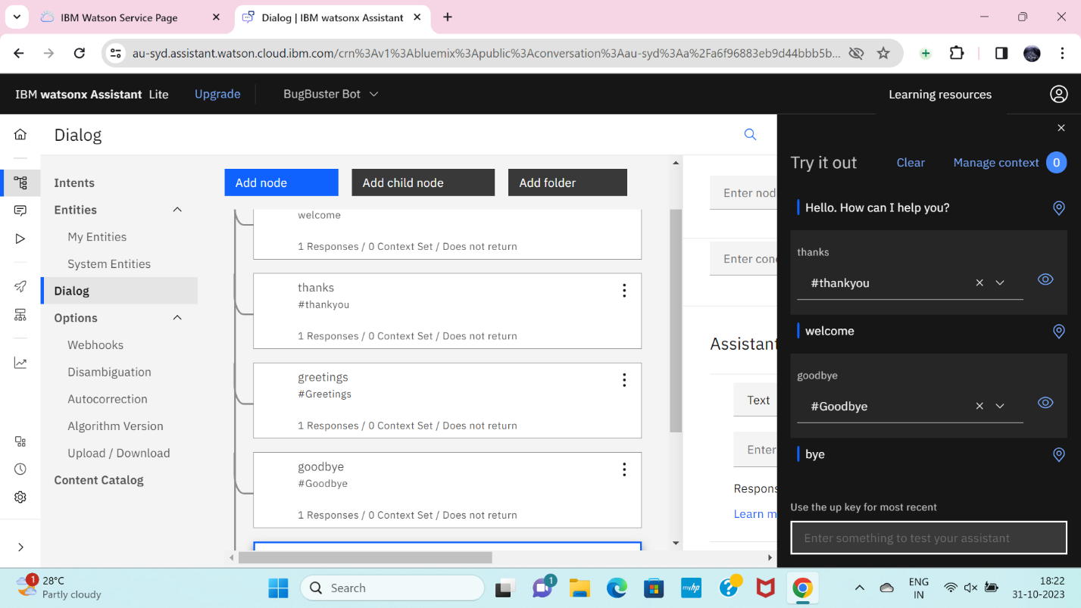

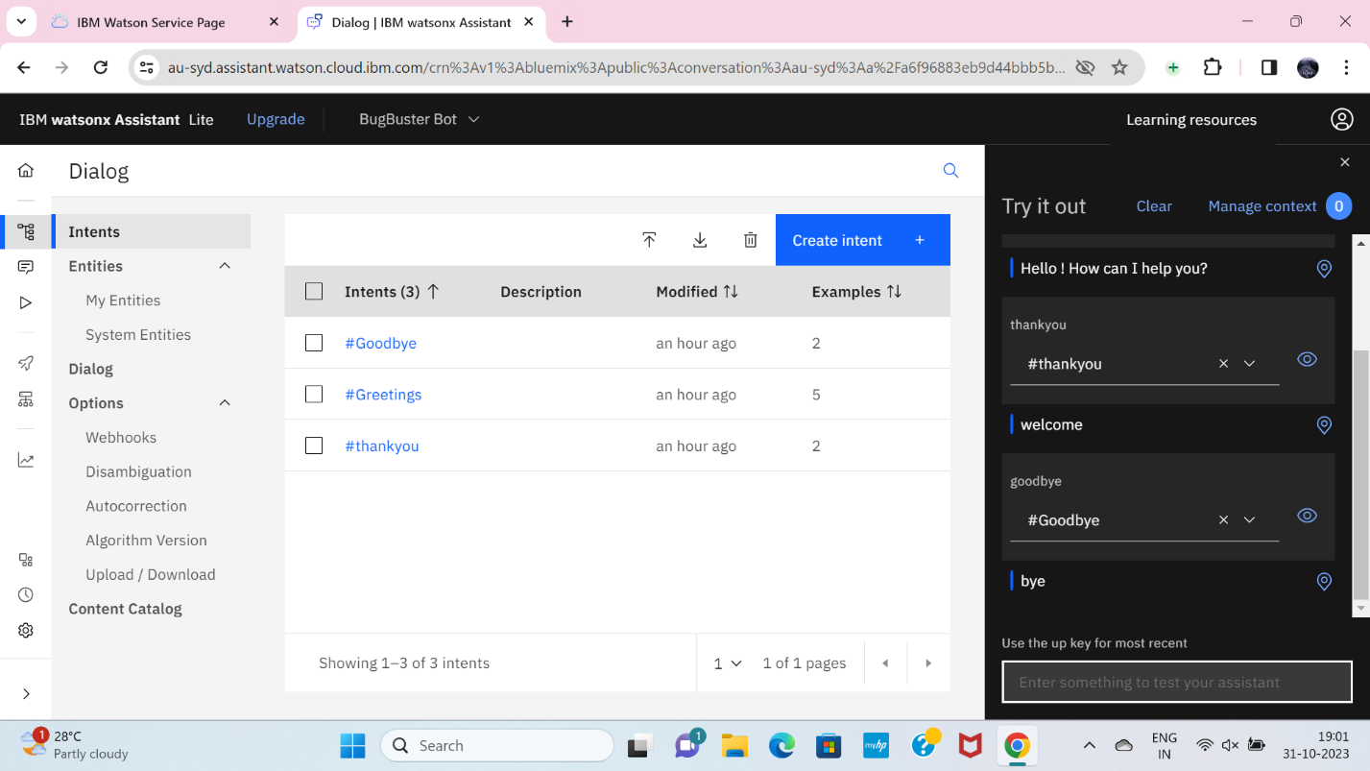

**STEP 9**

Create conversational flow

